Athens and Economic Sanctions Name: ___________________
In your own words, define the following terms. Try to do this without looking at your notes.

Economic Sanctions ____________________________________________________________________

Quota________________________________________________________________________________

Embargo _____________________________________________________________________________

Tariff ________________________________________________________________________________
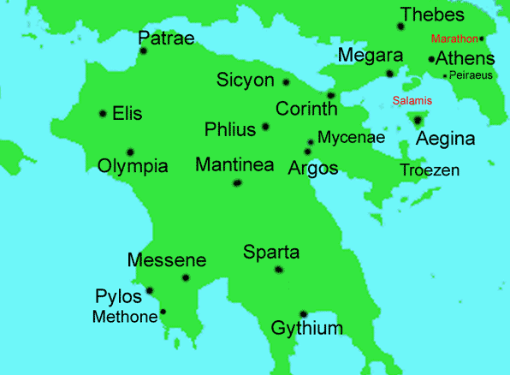
In 433 AD, Athens passed the The Megarian Decree which banned merchants from the Greek city-state of Megara from the Athenian markets. Athens made this policy because people that lived in Megaria (which bordered Athens) started settling on land that Athens claimed. Sparta went to war with Athens because it refused to lift the ban. Megara was an ally of Sparta and the Megarian Decree helped to start the Peloponnesian War – a war between the Delian and Peloponnesian Leagues.

- This is an example of economic sanctions because:

- What type of economic sanctions did Athens use? (Quota, Embargo, or Tariff) Explain.

- How might the actions of Athens affect the all people of Megara (not just the merchants?)

- How might the actions of Athens affect the people of Athens? Explain.

