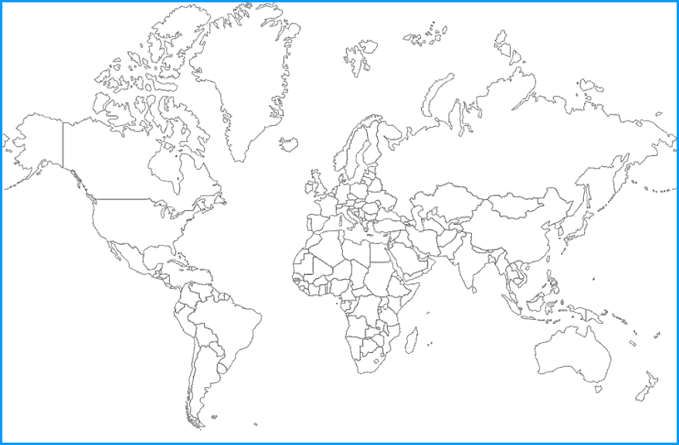

My cultural artifact is:
The topic I researched:
It originated from:

Name:

I learned the following information about its history and purpose:

It is or is not an example of cultural diffusion because:

