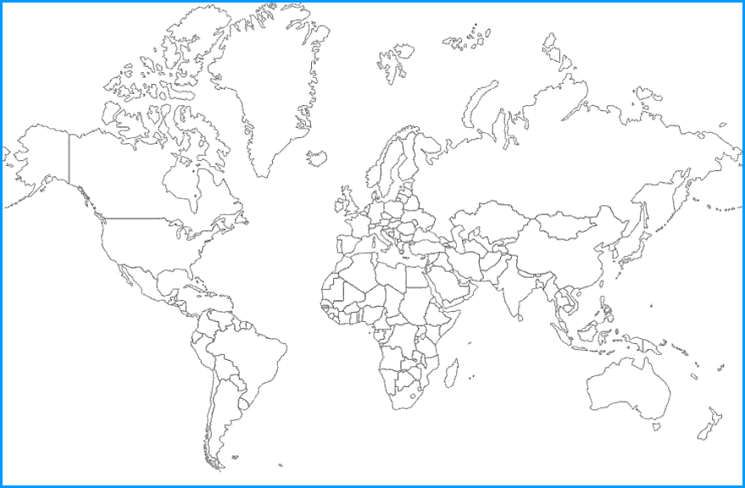

My cultural artifact is: Sweatshirt (it has a zipper)
The topic I researched: Zippers
It originated from: Chicago

Name: Mrs. Liljemark

I learned the following information about its history and purpose:
It was originally called a hookless fastener and has also been called a clasp locker, fly, zip, and zip fastener. It was invented in 1851 by an American in Illinois.

It is or is not an example of cultural diffusion because:
The idea of a zipper spread all the way up to Alaska. Now there are lots of clothes in Alaska that have zippers, where before people used to use other things to hold clothing together.

