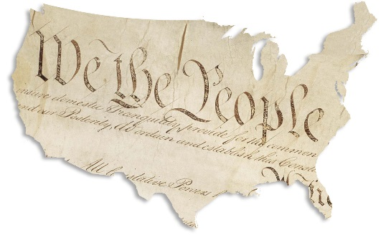
Government Unit Test Review
- Purpose of Government
  - Be able to recognize a state of nature and natural rights in examples
  - Know how the purpose of government relates to a state of nature and natural rights
__________________________________________________________________________________________
- Constitution – what is a constitution?
  - Compare the purpose of the US Constitution vs. the Declaration of Independence
  - Why do countries make constitutions?

- Articles of Confederation (pg. 206)
  - Why was the Articles of Confederation unsuccessful as our first constitution?

- Constitutional Convention
  - Great Compromise (Virginia and New Jersey Plans) (pg. 213)
  - 3/5 Compromise (pg. 215)
  - Electoral College – How does it determine who wins the president? (pg. 261)
__________________________________________________________________________________________
- US Constitution
  - Federalism – what? Be able to interpret examples and determine who has power to perform particular actions (pg. 268)
  - Separation of Powers – what? (pg. 256)
  - Checks and Balances – what? Why is it helpful in controlling power? (pg. 257)
  - Legislative Branch – power to do what? (pg. 258)
    - Congress, Senate, House of Representatives, Bicameral, Unicameral
  - Executive Branch – power to do what? (pg. 260)
    - Who makes up the Executive Branch?
  - Judicial Branch – power to do what? (pg. 262)
    - Who makes up the Judicial Branch?
  - Amendments – what? (pg. 264)
    - Bill of Rights – what?
    - Be able to apply to the Bill of Rights to examples

