Geography and Culture: Kenai Pen and Greece Name: ____________________
A LETS chart is a way of organizing cultural traits in order to understand the variety of characteristics that make up culture. In your small table group, create a LETS chart that identifies cultural characteristics of the Kenai Peninsula that are affected by geography. Then, individually read pages 300-301 in your textbook and complete the LETS chart for ancient Greece.
L | Language (dialect, accent, slang words, etc.)
E | Economy (how do the people make a living? What industries do they have?)
T | Technology (tools, transportation, housing)
S | Social Systems (government, arts/music, dance, clothing, entertainment, religion, social hierarchy, taboo, gender roles, marriages, holidays, etc.)

Kenai Peninsula LETS Chart
L
E
T
S

Ancient Greece LETS Chart
L
E
T
S
Compare the cultures of both the Kenai Peninsula and Ancient Greece. Use the information that you collected in your LETS charts to complete the Venn diagram.

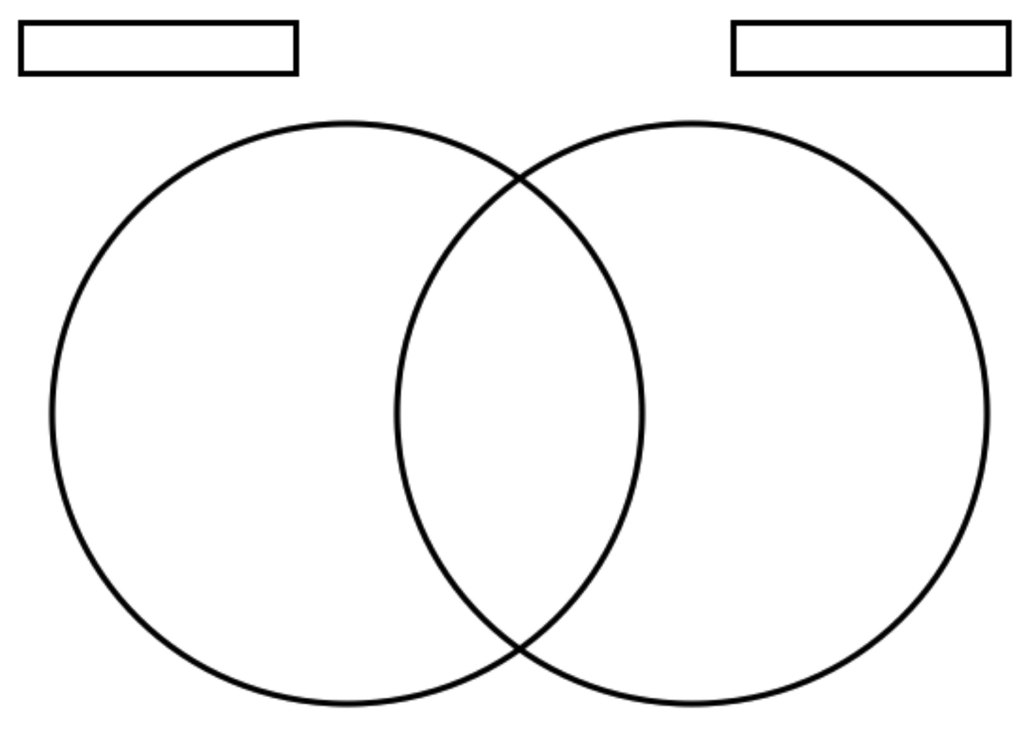

Rubric
 | 4 | 3 | 2 | 1
Concept Arrangement | Each section of the diagram contains four facts easily identified. | Each section of the diagram contains three facts easily identified. | Each section of the diagram contains two facts that are somewhat identified. | Each section of the diagram contains very few facts that are not easily identified.
Linking Content together | Reflects factual information that corresponds with appropriate section of diagram. | Most of the information is factual and seemingly corresponds with appropriate section of diagram. | Reflects some factual information and attempts to put it in corresponding section of diagram. | Contains non-factual information that does not correspond to the appropriate section of diagram

