Louisiana Purchase Name: _________________
Complete this handout after/while reading “The Louisiana Purchase” on pages 260-262 in your textbook. 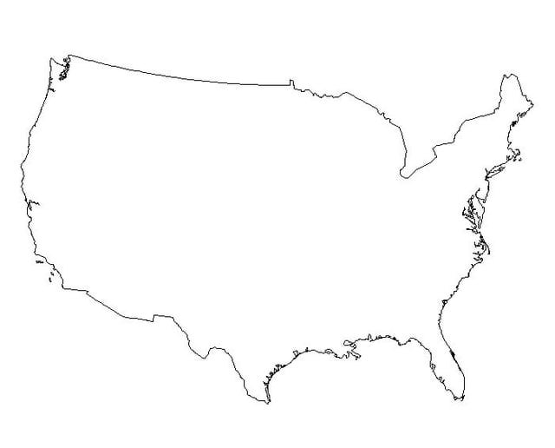
Draw and label on the map:
- The Mississippi River 5. Gulf of Mexico
- New Orleans 6. The route traveled by goods from farmland west of the App. Mts to
- Appalachian Mountains an Atlantic port (example, New York)
- Louisiana Purchase 7. Haiti
Answer the following questions in the space provided.
- Why was New Orleans and the Mississippi River important for farmers west of the Appalachian Mountains? Why did President Jefferson want to buy it?

- Cause and Effect: What did Napoleon want to use Louisiana for? What effect did losing Haiti have on Napoleon’s plans?

- Who sold Louisiana to the US and why?

- Why was Jefferson hesitant at first about purchasing Louisiana?

