Pull Factors of Irish Immigration Name: ___________________________
Read the provided handout “Pull Factors of Irish Immigration” and complete the Industrial Revolution timeline below. As you read consider how the US was changing and how those changes could affect immigration. The timeline for Irish immigration has already been completed for you.

Parallel Timeline

Irish Immigration Potato Famine
1815 1820 1825 1830 1835 1840 1845 1850 1855 1860
[-------------------------------------1st Wave of Irish Immigration---------------------------------------------] [------------------------2nd Wave of Irish Immigration ---------------]

Industrial Revolution
1815 1820 1825 1830 1835 1840 1845 1850 1855 1860

- First Textile Factory in the US is built
- Steam engines were designed to power machinery
- Interchangeable parts are created by Eli Whitney to reduce assembly costs
- Steam boats were widely used on major rivers
- Erie Canal begins construction
- Railroads become very popular and successful
- Hundreds of miles of rail road track span the North

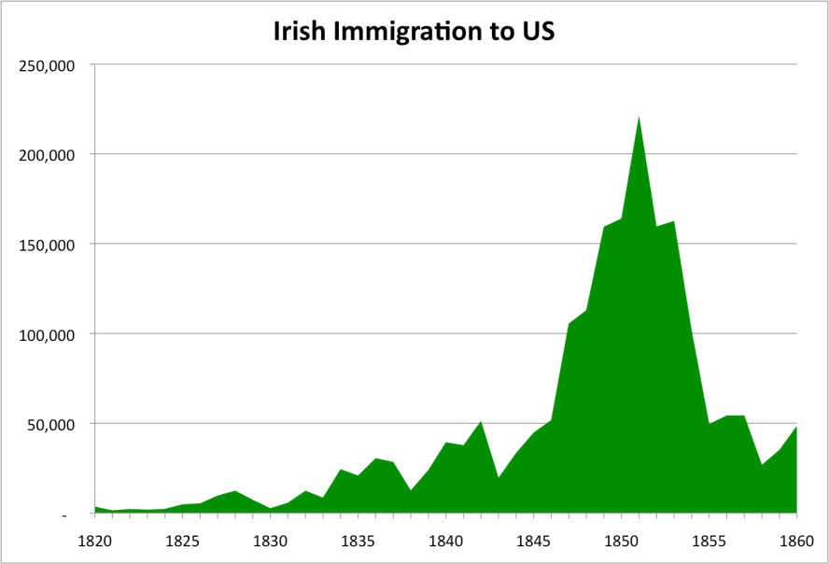
Use the graph above and the timelines on the other side of the paper to answer the following questions.
- It seems, from the graph above, that Irish immigration starts to gradually increase between 1820 and 1840. What is a possible cause to the increase in Irish immigrants to the US during this time? What may have pulled them to the US? Explain how it would have pulled them.

- The 1840s saw the highest numbers to Irish immigrants to the US (2nd Wave). Based on the timelines, what is one reason they may have been pulled to the US during that time? Explain why that would have drawn them.

