Purpose of Government Name: ___________________
8th Grade US History/Liljemark
Part 1:
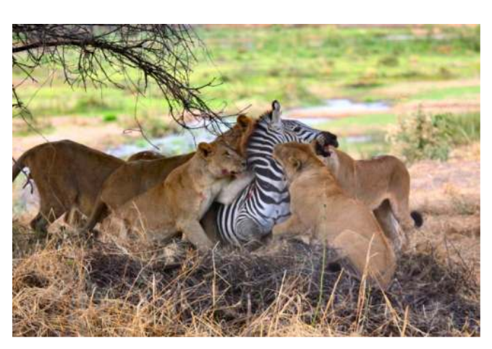

- Compare and contrast what is happening in these pictures. How are these situations similar? How are they different? Are they fair? Explain your answers

- These pictures represent something philosopher John Locke calls a “State of Nature.” Create a definition of what you think a “state of nature” is.

- What are the three “natural rights” that John Locke believed all humans have? You can find them in this famous line from the Declaration of Independence.
We hold these truths to be self-evident, that all men are created equal, that they are endowed by their Creator with certain unalienable Rights, that among these are Life, Liberty, and the pursuit of Happiness.

- Does a “state of nature” allow humans to have those rights? Explain your thoughts.

- How can humans be guranteed their natural rights? Choose one of the pictures above and draw it below, changing it so that the people or animals retain (or keep) their natural rights. In one sentence, explain how they retained their natural rights.

Part 2: International Governments
Use the links provided on the class website to explore how well you country’s government protects its citizen’s human rights. Please record what you find in the space below.

Part 3: Speed Dating
Pick one country that you would go on a date again with. In relation to human rights, why would you go on a date with them again?

Pick one country that you would NOT go on a date with again. In relation to human rights, why would you NOT go on a date with them again?

