Resistance to Slavery – Slave Experiences Name: ________________
Before we can explore how slaves and abolitionists resisted, we need a little more information on the life of slaves. Use pages 274, 275, 276, and 279 in the History Alive textbook to complete the following table. Complete the first section with the class.

Oppression
- the feeling of being weighed down or held back by severe and unfair force
- cruel or unjust treatment or force

 | Description of the experiences of slaves. | Examples of oppression
Slave Churches (pg 281)
Working Conditions (pg. 274)
Living Conditions (pg. 275)
Controlling Slaves (pg. 276)
Slave Families and Communities (pg. 279)

Now that you have read a little about slave life, let’s analyze the painting below.

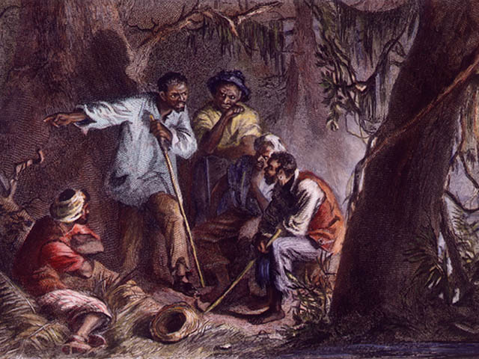
Observe: (I see….)

Reflect: (I think…. because I see….)

Questions: (I wonder…)

