The Minoans and Mediterranean Trade Name: _______________
The Minoan civilization developed on and ruled the island of Crete from about 3600 to 1400 BC. The Minoans established a great trading empire centered on Crete, which is conveniently located midway between Egypt, Greece, Turkey, and the Middle East. We know surprisingly little about this Minoan civilization, which flourished for nearly two thousand years. Indeed, we do not even know what these people called themselves. The term Minoan is a modern name, and comes from the legendary King Minos, who, according to Greek mythology, ruled the island of Crete. One of the main problems in understanding Minoan civilization is that, though we have Minoan writing, no one has deciphered it, so we do not know what it says. We can make up a bit for our lack of knowledge from texts with information gleaned from archaeology.
The island was probably first inhabited by people around 6000 BC. They grew wheat, olives, and grapes, herded sheep, and lived in small villages. Some of these settlements, over the course of thousands of years, began to grow large. By 3000 BC, some of these settlements had grown into larger towns, with trade and production taking place there. Craftsman at these towns began working in silver, gold, and bronze, and already some sea trade seems to have been taking place. They traded with Egypt, Turkey, and Lebanon, for copper, tin, ivory, and gold.
From 1900-1700 BC the first palaces were built on Crete. All of them were built around the same time, and all very close to the sea. Outside the palaces were smaller settlements, which were connected with early paved roads. This period probably saw the emergence of kings as rulers of various areas on Crete, as well as a hierarchical society, with nobles, peasants, and slaves. During this period, the Minoans began to expand their trade networks. It seems they had close contacts with Middle Kingdom Egypt. The Minoans also established some of their first trading colonies on other islands, mostly in the Aegean Sea. It is also in this period that the first signs of Linear A, the Minoan written language, appear. Written mostly on clay tablets, it probably evolved from hieroglyphic writing.
Later Minoan trade networks grew even larger, and it can be said that they developed an early maritime trade empire. They settled more overseas colonies, and established such close trade contacts with Egypt that Minoans are depicted in Egyptian paintings. They also seem to have traded for amber from northern Europe and precious stones from the Far East (possibly China). Minoan influence became very strong in Greece, and elsewhere in the eastern Mediterranean. In 2009, a city with strong signs of Minoan influence was excavated in modern-day Israel, revealing just how far Minoan culture spread.

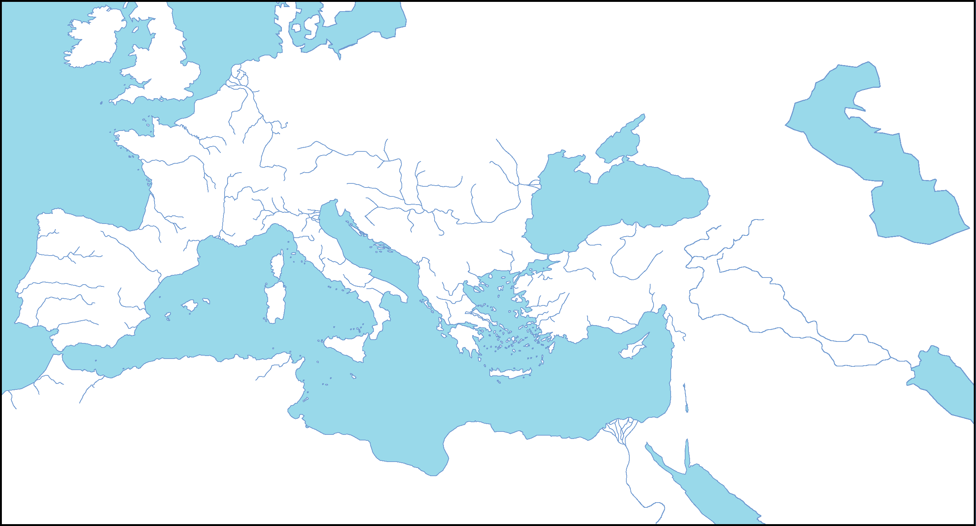

- On the map above, identify and label Crete. How did Crete’s location help the Minoans trade?

- Between 6000 BC and 3000 BC industry on Crete began to advance. On the map indicate (with a solid line) who the Minoans traded with and the goods that they possibly exported.

- Between 1900-1700 BC Minoan trade continued to spread. Indicate on the map (with a dashed line) where their trade spread.

- The final paragraph talks about the continued spread of trade. Indicate on the (with a dotted line) who they traded with and identify some of their imports. (Make sure that you consider HOW they traded, and physical geographic features when drawing your path of trade.)

- The article talks about how the Minoans established “colonies.” Circle the region that where they established their first colonies (1900-1700 BC).

- My definition of a colony is:

- The dictionary definition of a colony is:

