Understanding Economic Depression 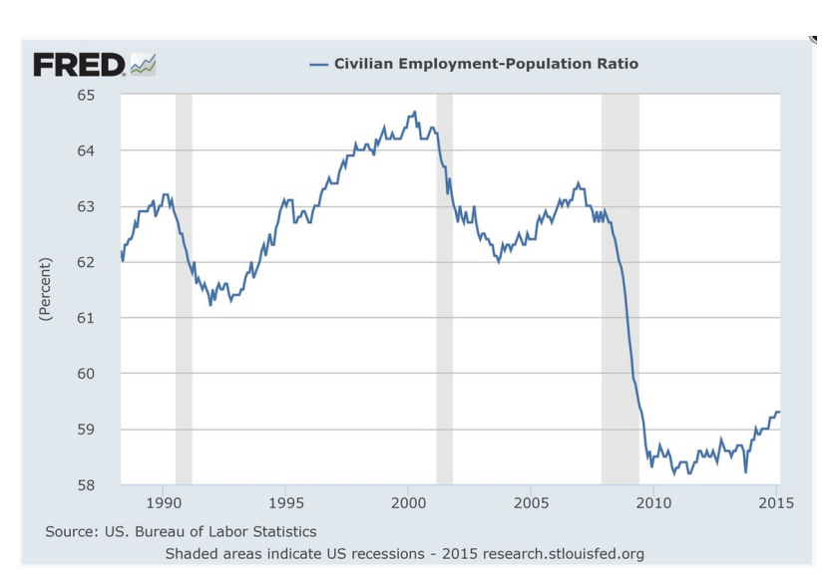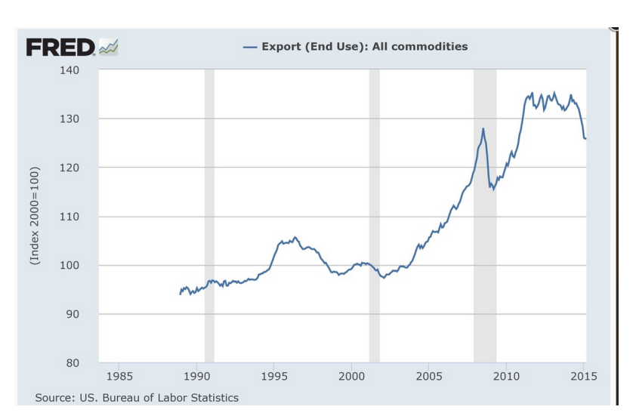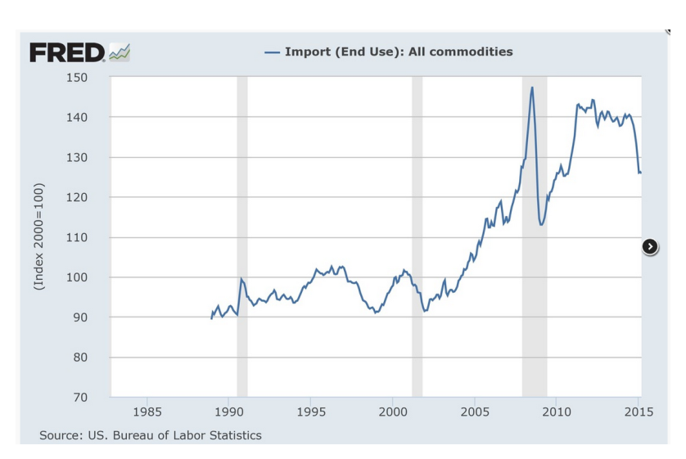

Name: _________________________________
- What happens to US exports in 2008?

- What happens to employment rates in 2008?

- Compare US exports and employment rates in 2008. Based on the data, what can you infer about what is happening in the US during that time.

- Describe import rates in 2008.

- Compare the import rates with the export and unemployment rates. What can you infer based on this data?

- Notice that from 2010 to 2015 export and import rates go up, but unemployment stays low. Hypothesize why.

